 |  | Autumn 1 |  | Autumn 2 | Spring 1 |  | Spring 2 | Summer 1 | Summer 2
 | Topic | Me and My Community |  |  | Our Kingdom |  |  | Life in the Past
 | Text | 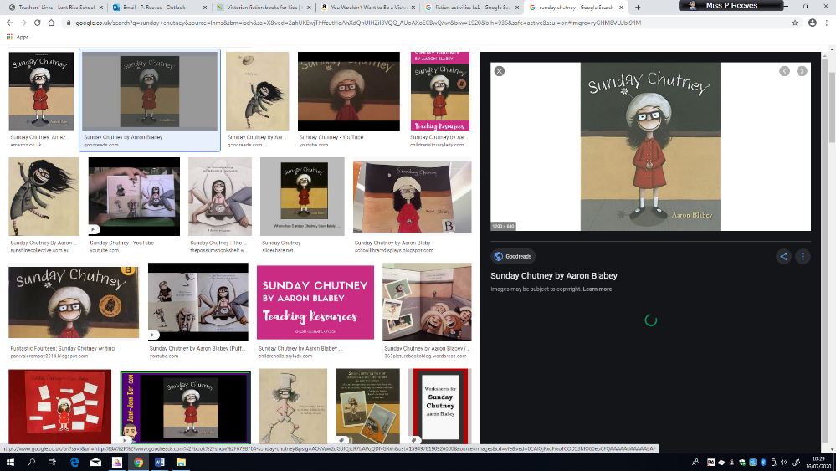  Sunday Chutney |   The day the crayon quit |  | 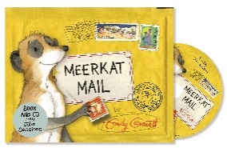  Meerkat Mail | 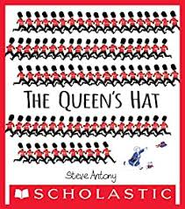  The Queens Hat |  | 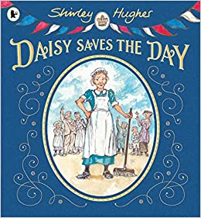  Daisy saves the day | 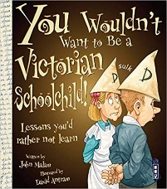  You wouldn’t want to be a Victorian school child
Genre | Fiction | Story sequencing  P4C – discussions |  |  | Comprehension  P4C – discussions |  |  | Story writing  Role play  Fact file
 | Non Fiction | Letter writing  Comprehension |  |  | Recount  Fact file |  |  | Letter writing  Timeline of historical events  Features of a text
 | Poetry | James Carter Poet – National Poetry Day |  |  | Shape poem  Rhyming – traditional tales |  |  | Acrostic poem

Writing Genre Overview – Year 1

Writing Genre Overview – Year 2

 |  | Autumn 1 | Autumn 2 | Spring 1 | Spring 2 | Summer 1 | Summer 2
 | Topic | A Journey Through Time |  | The World Around Us |  | London’s Burning!
 | Text | The BFG  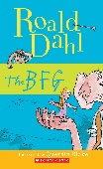 |  | 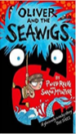  Oliver and the Seawigs |  | 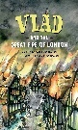  Vlad and the Great Fire of London | Revolting Rhymes  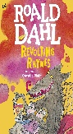
Genre | Fiction | Recount  Narrative  Predictions  Descriptions: characters, settings |  | Recount – Postcard  Narrative – adventure  Predictions  Extended stories – comparisons between different texts  Descriptions: characters, settings |  | Historical Recount  Sequencing | Narrative – Traditional and fractured fairytales  Stories with familiar settings  Story writing
 | Non Fiction | Discussion/ persuasive letter writing  Key Question: The BFG knew it was not right to steal cauliflower, but thought it was ok to take Sophie as she was only a little girl. Discuss. |  | Explanation  Non-Chronological Report - Brochure  Persuasive - letter writing |  | Instructions  Non-Chronological Report – Fact File  Leaflets
 | Poetry | Descriptive Poetry  James Carter Poet – National Poetry Day |  | Descriptive Poetry  Shape Poetry |  | Acrostic Poetry  Rhyming Poetry  Performance Poetry

Writing Genre Overview – Year 3
 |  | Autumn 1 | Autumn 2 | Spring 1 | Spring 2 | Summer 1 | Summer 2
 | Topic | Amazon Adventures | Savage Stone Age | Romans on a Rampage |  | Legends, Monsters and Magic
 | Text | 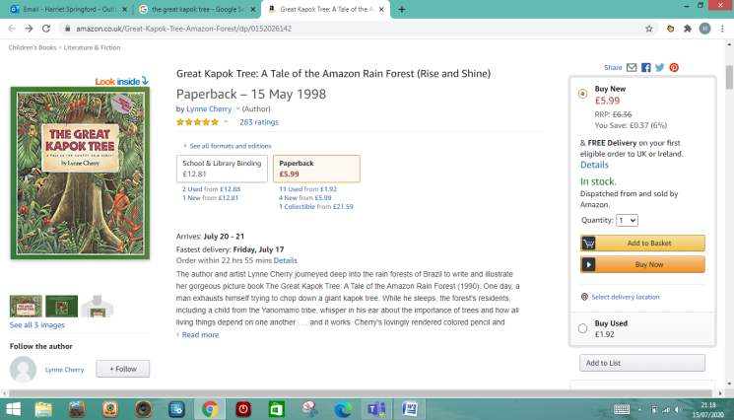  The Great Kapok Tree | Stone Age Boy  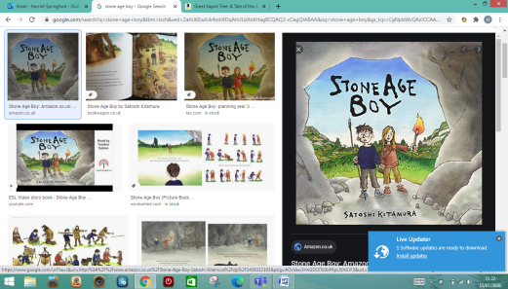 | Roman Diary- The journal of Iliona  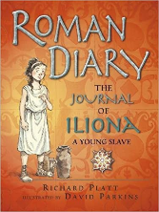 | Boudicca’s Army (I Was There)  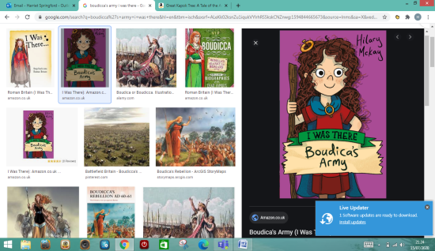 | King Arthur  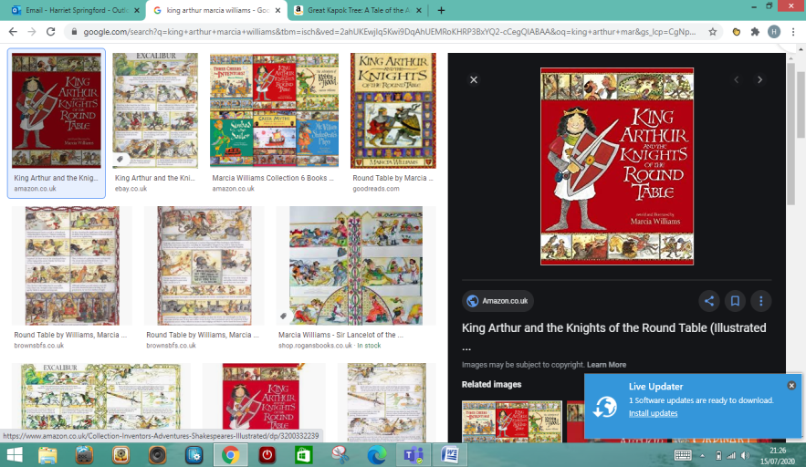 | Beowulf  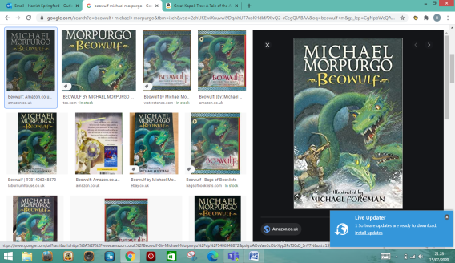
Genre | Fiction | Descriptive writing | Play scripts  Narrative – adventure stories | Narrative – Roman myths  Diary entries |  | Narrative - legends
 | Non Fiction | Persuasive writing – argument  Non-chronological report –rainforests | Instructions  Letters | Newspaper reports  Biographies |  | Information text  Persuasive writing - advert
 | Poetry | James Carter Poet – National Poetry Day  Descriptive poetry – rainforest |  | Shape Poetry  Calligrams |  | Language play  Performance Poetry

Writing Genre Overview – Year 4

 |  | Autumn 1 | Autumn 2 | Spring 1 | Spring 2 | Summer 1 | Summer 2
 | Topic | Vicious Vikings |  | Ancient Egyptians |  | Ocean Explorers
 | Text | The Saga of Erik the Viking/  There’s a Viking in my bed  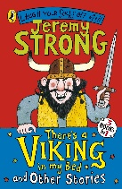  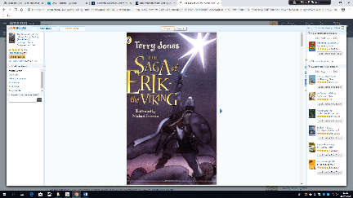 |  | The Egyptian Cinderella  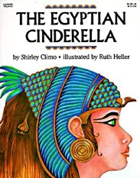 |  | Song of the Dolphin Boy  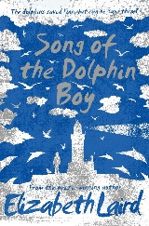
Genre | Fiction | Character descriptions  Stories with historical settings |  | Stories from other cultures  Stories which raise issues/dilemmas |  | Stories set in imaginary worlds  Plays
 | Non Fiction | Persuasive texts  Newspaper reports |  | Explanation texts |  | Information texts
 | Poetry | James Carter Poet – National Poetry Day |  | Creating images |  | Exploring form

Writing Genre Overview – Year 5
 |  | Autumn 1 | Autumn 2 | Spring 1 | Spring 2 | Summer 1 | Summer 2
 | Topic | WW2 |  | Ancient Civilisations |  | Out of this world
 | Text | Goodnight Mister Tom  The Emergency Zoo  The Lion and the Unicorn  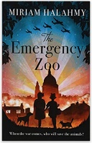    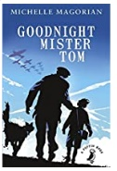 |  | Percy Jackson and the lightning thief  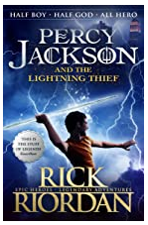 |  | Range of non-fiction texts
Genre | Fiction | Recount  Narrative  Historical Recount  Character analogy  Prequels |  | Recount  Narrative – alternative endings  Character analogy  Letter Writing |  | Narrative – developing own world, writing at length and creating own story  Prequels  Letter Writing
 | Non Fiction | Discussion / persuasive letter writing  Writing in role  Letter Writing |  | Explanation  Non-Chronological Report  Brochure  Persuasive - letter writing  Writing in role |  | Instructions  Writing in role  Non-Chronological Report  Fact File  Letter Writing
 | Poetry | Descriptive Poetry  Classic and narrative poems |  | Descriptive Poetry |  | Acrostic Poetry  Rhyming Poetry  Performance Poetry

Writing Genre Overview – Year 6

 |  | Autumn 1 | Autumn 2 | Spring 1 | Spring 2 | Summer 1 | Summer 2
 | Topic
 | Text | Kensuke’s Kingdom   |  | Stone Girl Bone Girl  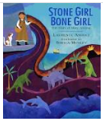 |  | Holes  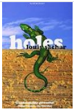
Genre | Fiction | Extending narrative  Authors and texts  Short stories with flashbacks |  | Extending narrative  Authors and texts  Stories with flashbacks  Recounts |  | The power of imagery  Finding a voice
 | Non Fiction | Non-chronological reports  Journalistic writing  Persuasion  Argument/ discussion  Newspapers  Accounts of key events  Instructions |  | Biography and autobiography  Journalistic writing  Information leaflets/ holiday brochures  Advertisements  Formal/impersonal writing  Accounts of key events  Relating significant discoveries |  | Non-chronological reports  Reviews (Books/ films)  Letters  Emails  Blogs
 | Poetry | Haiku – Japanese Poetry  Syllables, mood, moment, tense, imagery |  | Elegies and Odes  Loss and tributes - linked to Stone Girl Bone Girl |  | The Highwayman – Alfred Noyes  Descriptive Poetry

