Lent Rise School

Design and Technology
Policy 2023-24

Responsibility: | Miss K Vessey

Approved by:
Mrs Maggie Young, Chair of Governors
Mrs Jill Watson, Headteacher

April 2024

Introduction

This Policy has been written in accordance with the requirements of the National Curriculum. It provides a statement and a reference for the Design and Technology that is taught throughout the school. It has been compiled by the subject coordinator in conjunction with all members of the teaching staff to ensure the best quality of teaching and learning opportunities are provided to each child.

Nature of the Subject

At Lent Rise School, our intent is to deliver a wide, skills-based curriculum that equips pupils with the knowledge and understanding that they can apply in later life. We want all our pupils to be equipped for learning and to develop critical thinking skills that enable them to make good choices and reflect and reason. Our pupils work with ambition in a safe and secure environment.

Our Design and Technology curriculum is planned to ensure aspirations and ambition for all our pupils is attainable. The pupils will learn how to be resilient and effective learners. We encourage children to use their creativity and imagination, to design and make products that solve real and relevant problems within a variety of contexts, considering their own and others’ needs, wants and values. Our pupils will learn that safety is paramount when developing and making their products.

Through the Design and Technology curriculum, the pupils will be able to develop ideas and produce products fit for a purpose, exploring their products beforehand in depth, and in a variety of ways. The children will evaluate their products based on either consumer research or design criteria and confidently explain the reasons for their choices. Through the evaluation of past and present design and technology, our pupils will develop a critical understanding of its impact on daily life and the wider world. Their experiences will prepare them with hope and confidence for the future.

Aims

Design and Technology is an area of the curriculum through which many of the aims of the school can be achieved; by working collectively or individually they will develop skills, attitudes and concepts as well as tolerance, care and understanding. We, as educators, teach children through showing, rather than just telling.

The teaching of Design and Technology at Lent Rise School aims to:

- Give pupils the confidence and competence to identify, examine and solve practical problems involving products using a variety of approaches, materials and methods.

- Give pupils a sense of enjoyment and pride in their ability to design and make.

- Develop pupils’ understanding through discovery and first-hand experience what their environment is about, and what makes it work, and appreciate the ways in which products might be controlled and how they might be made to work more effectively,

- Encourage the openness of mind and flexibility to meet challenges, to put to use elements of the pupils’ previous learning and experience, which will enable them to solve problems satisfactorily, within their capabilities.

- Make pupils aware of the essential similarities and difference between designing and making in school and in industry and commerce and an awareness of techniques, approaches, materials and methods of the modern technological world.

- Help pupils develop the social skills required to work as a member of a team as well as the ability to work independently when the situation demands it.

- Develop levels of imagination, inventiveness and creativity by means of materials and language that make the process more conscious and communicable thus developing the pupils’ ability to communicate in practical contexts (vocabulary).

- Give the opportunity to develop the intellectual (estimation, prediction, results, logical thinking and reflection), creative, practical and manipulative skills needed in Design and Technology to achieve a solution to a problem; to encourage pupils to make judgements of the aesthetic, economic, social and technological quality of their own work and that of others.

- Encourage respect for the ways in which people of different cultural backgrounds, past and present, have shown their ability to enrich their environment.

- Encourage an awareness of Design and Technology across the curriculum as a whole.

- Include all pupils in the school community, regardless of ability.

Teaching and Learning Strategies

Teaching should ensure that knowledge and understanding are applied when developing ideas, planning, making, and evaluating products. Effective teaching aims to provide opportunities for children to:

- Develop, plan and communicate ideas
- Acquire knowledge and understanding of materials and components
- Work with tools, equipment, materials and components to make quality products
- Use problem-solving and thinking skills
- Persevere to solve the problems that are encountered when designing and making products
- Evaluate the processes used and the products made
- Work collaboratively, co-operate effectively, and accept corporate responsibility when working as part of a team to design and make products.

In Design and Technology, the teacher must reconcile two conflicting demands:

- That of giving the maximum freedom for the pupil to develop their ideas; and providing structured experiences to achieve intended learning objectives. There are professional decisions to be made in striking a balance between these whilst keeping in mind essential guiding principles.

- Foremost must be the ability to develop inventive and lively minds through appropriate stimuli. This will require that Design and Technology must be presented in an exciting, interesting and challenging way. There is an obvious need to liaise and combine working schemes with other subject areas where appropriate, including Art and Design, Mathematics and Science.

Through the teaching of Design and Technology, the teacher aims to ensure the child has:

- Secure knowledge and understanding through the technological accuracy of the content of the lessons, and through the competent and effective demonstration of skills and techniques using tools and equipment.

- Appropriate expectations with emphasis on high standards – quality of finished product, accuracy, attention to detail and finish and evaluation of product against the original design specification.

- Correct use of technical terminology

- An awareness of the health and safety measures included within the design and making of each product

ICT Opportunities

ICT should be used in the teaching of Design and Technology wherever the opportunity arises.

ICT can help children’s learning in Design and Technology:

- by enhancing their skills in designing and making
- by providing a range of information sources
- by supporting the development of their understanding of sequencing and control systems
- by collecting and presenting information
- by providing access to images of people, placed and environments
- by presenting their design
- by contributing to children’s awareness of the impact of ICT on the changing world

Our progression of skills ensures that this is achievable, particularly in KS2.

The Requirements of the National Curriculum

In order to continue to develop the standard of Design and Technology in the school, the subject is taught in alternate half terms to Art and Design in order to focus on the subject specifically. However, individual teachers may use additional curriculum time for further Design and Technology teaching. The organisation of Design and Technology teaching is clearly outlined in the schemes of work and in weekly plans.

There is a weekly allocation of time for each Key Stage:

Key Stage 1 (33 hours) 1 hour
Minimum
Key Stage 2 (45 hours) 1.25 hours

Lessons are timetabled on a half termly basis and copies of these are held by the Headteacher and Key Stage Manager to ensure this occurs.

Key Stage One Programme of Study

Through a variety of creative and practical activities, pupils should be taught the knowledge, understanding and skills needed to engage in an iterative process of designing and making. They should work in a range of relevant contexts [for example, the home and school, gardens and playgrounds, the local community, industry and the wider environment].
When designing and making, pupils should be taught to:

Design
- design purposeful, functional, appealing products for themselves and other users based on design criteria
- generate, develop, model and communicate their ideas through talking, drawing, templates, mock-ups and, where appropriate, information and communication technology

Make
- select from and use a range of tools and equipment to perform practical tasks [for example, cutting, shaping, joining and finishing]
- select from and use a wide range of materials and components, including construction materials, textiles and ingredients, according to their characteristics

Evaluate
- explore and evaluate a range of existing products
- evaluate their ideas and products against design criteria

Technical knowledge
- build structures, exploring how they can be made stronger, stiffer and more stable
- explore and use mechanisms [for example, levers, sliders, wheels and axles] in their products

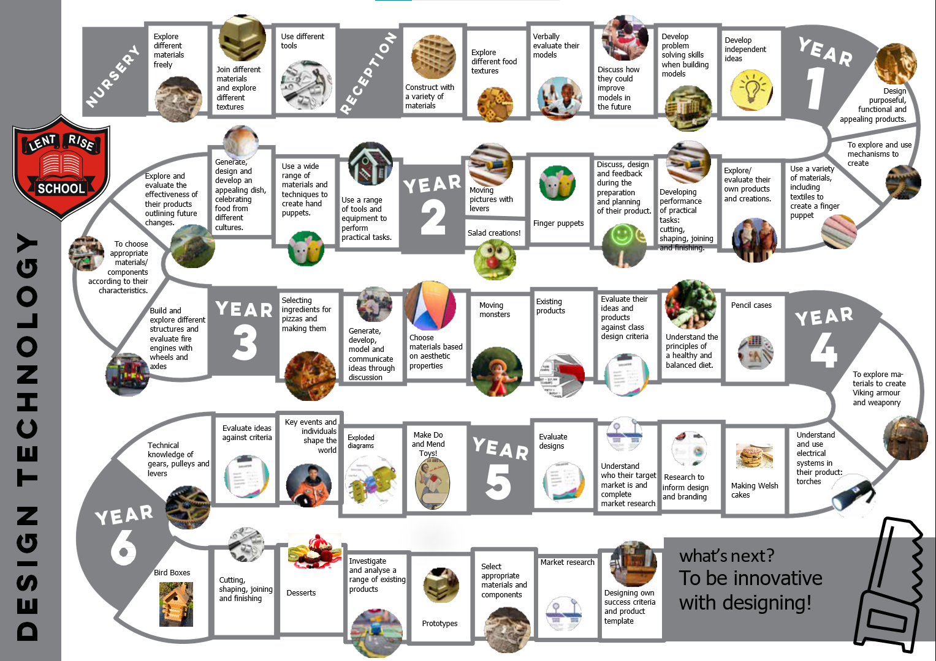

Key Stage Two Programme of Study

Through a variety of creative and practical activities, pupils should be taught the knowledge, understanding and skills needed to engage in an iterative process of designing and making. They should work in a range of relevant contexts [for example, the home, school, leisure, culture, enterprise, industry and the wider environment].
When designing and making, pupils should be taught to:

Design
- use research and develop design criteria to inform the design of innovative, functional, appealing products that are fit for purpose, aimed at particular individuals or groups
- generate, develop, model and communicate their ideas through discussion, annotated sketches, cross-sectional and exploded diagrams, prototypes, pattern pieces and computer-aided design

Make
- select from and use a wider range of tools and equipment to perform practical tasks [for example, cutting, shaping, joining and finishing], accurately
- select from and use a wider range of materials and components, including construction materials, textiles and ingredients, according to their functional properties and aesthetic qualities

Evaluate
- investigate and analyse a range of existing products
- evaluate their ideas and products against their own design criteria and consider the views of others to improve their work
- understand how key events and individuals in design and technology have helped shape the world

Technical knowledge
- apply their understanding of how to strengthen, stiffen and reinforce more complex structures
- understand and use mechanical systems in their products [for example, gears, pulleys, cams, levers and linkages]
- understand and use electrical systems in their products [for example, series circuits incorporating switches, bulbs, buzzers and motors]
- apply their understanding of computing to program, monitor and control their products

Cooking and Nutrition

As part of their work with food, pupils should be taught how to cook and apply the principles of nutrition and healthy eating. Instilling a love of cooking in pupils will also open a door to one of the great expressions of human creativity. Learning how to cook is a crucial life skill that enables pupils to feed themselves and others affordably and well, now and in later life.

Pupils should be taught to:

Key stage 1
- Use the basic principles of a healthy and varied diet to prepare dishes
- Understand where food comes from.

Key stage 2
- Understand and apply the principles of a healthy and varied diet
- Prepare and cook a variety of predominantly savoury dishes using a range of cooking techniques
- Understand seasonality, and know where and how a variety of ingredients are grown, reared, caught and processed.

Breadth of Study

The Design and Technology units taught at Lent Rise School have been selected to ensure that the areas being studied cover all of the knowledge, skills and understanding required at each Key Stage as listed in the Programmes of Study.

Planning
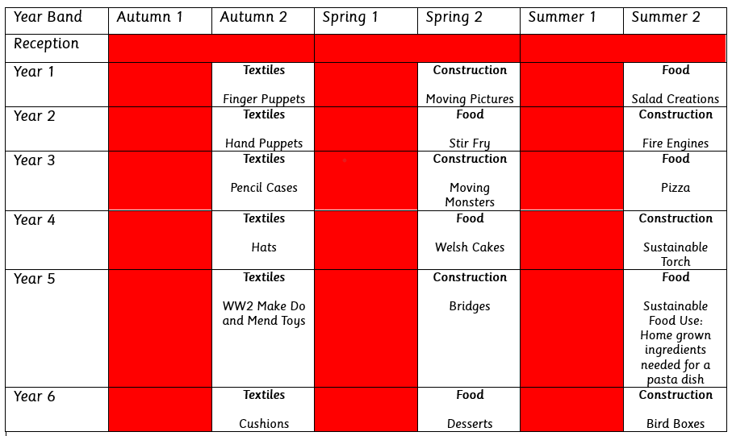

Every term, a long-term plan is produced, which outlines work to be covered in all areas of the curriculum. Each year group uses the national curriculum as the basis for their planning. A progression of skills document was produced to ensure continuity across the school and to allow children to develop their skills within DT lessons. A weekly plan is also produced on a grid to show the precise content of each unit of study. Weekly plans are kept in year group folders on the shared drive.

Each year group completes 3 projects per term. Each project is designed to be taught over a term or less, the units could be delivered during weekly sessions of an hour, but some may be more effectively delivered in half day blocks over half a term.

The teaching activities planned should include the three types of activity identified in the programmes of study and which interlink to make up a unit of work.

- Investigative and Evaluative Activities (IEAs)

To learn about existing products and D&T in the wider world through some use of research (more KS2)

- Focused tasks (FTs)

To provide the opportunity to be taught technical knowledge, designing skills and making skills.

- Design, make and Evaluative Assignment (DMEA)

To provide an opportunity for children to create functional products with users and purposes in mind.

Effective planning will ensure that:-
The children have the opportunity of working in groups, thereby gaining valuable experience in co-operating with others, or working alone to reach a solution to a particular problem.

The teaching of Design and Technology encompasses activities of relevance to pupils and it is essential that they have experience in working in a balanced range of contexts. It will be important for teachers to guide children in their choice of tasks towards contexts and activities which do not reinforce stereotypes and which extend their capabilities and range of interests beyond conventional horizons.

Links are established with other subjects by providing opportunities to reinforce what the children have been doing during the literacy hour and applying this in a different context. Teachers should take account of the explicit links identified for Science, Geography, History and Art and Design within the units of work.

Cross-Curricular Links

English – Discussion gives opportunities for speaking and listening.
Design and technology provides stimulus for non-fiction writing, often in the form of instructions and evaluations.
Opportunities to explore advertisements and persuasion.

Maths – Observation and use of shapes and patterns.

Science - Planning and making processes give opportunities for the children to select appropriate materials for the task according to their properties.
Units associated with food in Design and Technology reinforces science learning about healthy eating and growing.
Design and Technology work with electrical components supports science learning about circuits and electricity.
Making moving objects allows the children to explore the science topics of forces and motion further.

Art - Designing phase requires accurate drawings to be completed.
Creatively decorating finished pieces.

ICT - Use of ‘TinkerCad, ‘Photoshop Elements’, digital cameras and the internet.

PSHRE - Healthy eating and safety in the classroom whilst using equipment.

Design and technology is also used to raise children’s appreciation of fundamental British values.

Catering For Individual Needs

Teachers plan their Design and Technology with individual needs in mind.

Equal Opportunities

To provide effective learning opportunities for all pupils; staff will modify Design and Technology programmes of study by:

- Planning alternative tasks to overcome any difficulties arising from specific religious beliefs they may hold in relation to the ideas or experiences they are expected to represent.

- Planning alternative or adapted activities to overcome difficulties with manipulating tools, equipment or materials (for example, the use of computer-aided design and manufacture to produce quality products or the assistance of others to carry out activities according to the instructions of the pupil)

Also see Equal Opportunities Policy.

Children with Special Educational Needs

Design and Technology is very important for pupils with Special Educational Needs in this school. It offers opportunities for pupils to prepare to participate in tomorrow’s rapidly changing technologies. Pupils learn to think and intervene creatively to improve their quality of life, without being overly dependent on language skills.

To provide effective learning opportunities for all pupils; staff will modify Design and Technology programmes of study by:

- Providing specific support to enable pupils to engage in certain practical activities (for example, technological aids or specialist ICT software to help with sequencing and following instructions)

- Providing opportunities to communicate through means other than writing or drawing; and help to record or translate their design ideas into a drawing

- Providing opportunities to work in ways that avoid contact with materials that pupils may be allergic to

- Dedicating time and opportunity to using non-visual means; to gain understanding about, and to evaluate, different products and use this information to gain ideas

- Providing more time than for others to complete the range of work indicated in breadth of study (for example, by doing shorter assignments, by combining experience in more than one material in an assignment)

To provide effective assessments for pupils with Special Educational Needs teachers will take into account that pupils who are unable to use tools will be unable to achieve certain aspects of the attainment target. When a judgement against assessment indicators is required, assessment of progress should either discount aspects that relate to the use of tools or indicate the levels of support that are necessary to complete this work.

Gifted and Talented Pupils

Gifted and talented pupils require further extension and access to a range of materials and engaging challenges to develop their enjoyment and achievement in design and technology. In response to this teachers are encouraged to recognise gifted and talented pupils at the earliest possible stage so that additional provision can be made. If teachers are aware of gifted and talented children they should inform the D&T coordinator.

- Pupils identified as gifted and talented should tackle more complex design briefs and they should be given the opportunity to deepen and broaden their knowledge by using a wider and more demanding range of resources.
- All pupils are offered opportunities to take ownership of ‘design and make’ activities to allow the gifted and talented pupils to develop their particular talents.
- Extension activities are offered to develop skills at a more advanced level than those of their peers.
- Curriculum challenges are provided on the Lent Rise Learning World for children to experiment with ideas, styles and materials in the completion of engaging projects. Work is submitted to and monitored by the D&T coordinator.

Assessment

Pupils’ understanding is assessed through weekly work, both oral and written, as well as through example pieces of work which are then assessed against National Curriculum guidance.

Children’s understanding is assessed at every stage in order to:

- Identify what has been taught/learnt.
- Monitor individual progress.
- Provide a basis for further planning and teaching.

Assessment Methods

- Marking assignments or work recorded in sketch and floor books
- Individual, group or class discussions or observations
- Formal assessment
- Pupil’s personal evaluations

Recording

- Sketch/floorbook work
  - Moderated work is kept by the Design and Technology Co-ordinator as a guide for assessing levels of attainment
  - Annual written report to parents
  - Twice yearly teacher-parent consultations

The Role of the Design and Technology Co-ordinator

It is the Design and Technology Co-ordinator’s role to:

- Inspire learning through bringing design and technology alive for our children;
- Monitor and evaluate the learning and teaching of design and technology within the school;
- Devise an action plan to show future developments and review progress;
- Provide specialist support and guidance to colleagues on teaching projects and planning;
- Purchase and organise resources and maintain equipment to make them easily accessible for colleagues;
- Attend courses for CPD and report back to staff;
- Explore ways to raise the profile of design and technology within the school and make links with local businesses;
- Encourage parents to be involved in their children’s learning in design and technology.

